VLSI (Very Large Scale Integration) Internship – TASK 02
Title: Introduction to Verilog HDL and RTL Design of Basic Combinational Circuits
Tool Used: Icarus
Objective: To design and implement basic combinational digital circuits such as logic gates, half adder, and full adder using Verilog HDL and to verify the designs through testbenches, simulation, and waveform analysis.
- Simulation Results

- AND Gate
- The AND gate produces a HIGH output only when both inputs are HIGH.
- Y=A⋅B
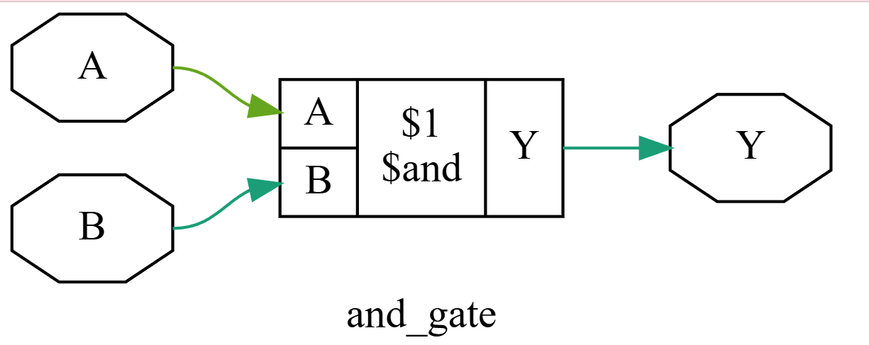
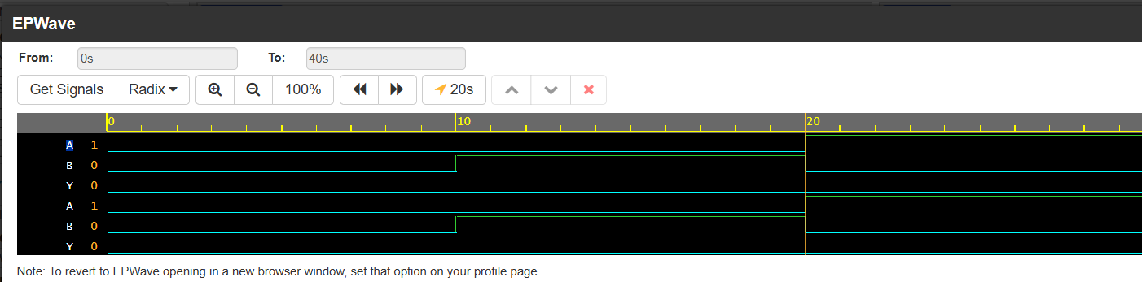
- OR Gate
- The OR gate produces a HIGH output when at least one of the inputs is HIGH.
- Y=A+B
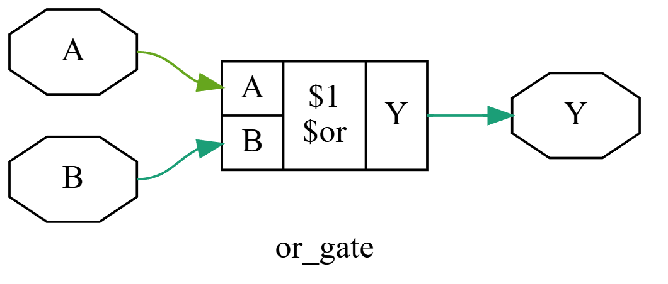
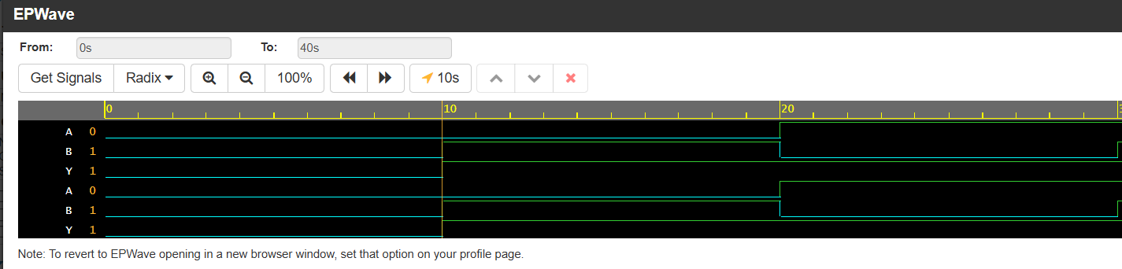
- NOT Gate
- The NOT gate has a single input and produces the complement of the input.
- Y=A‾
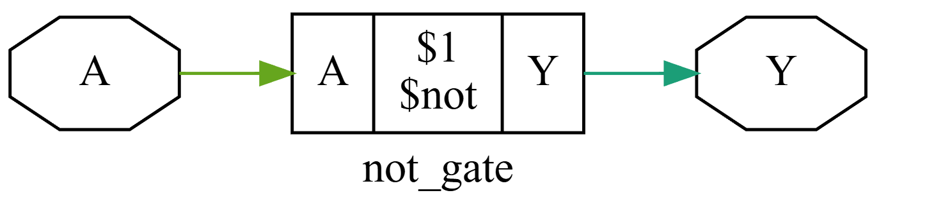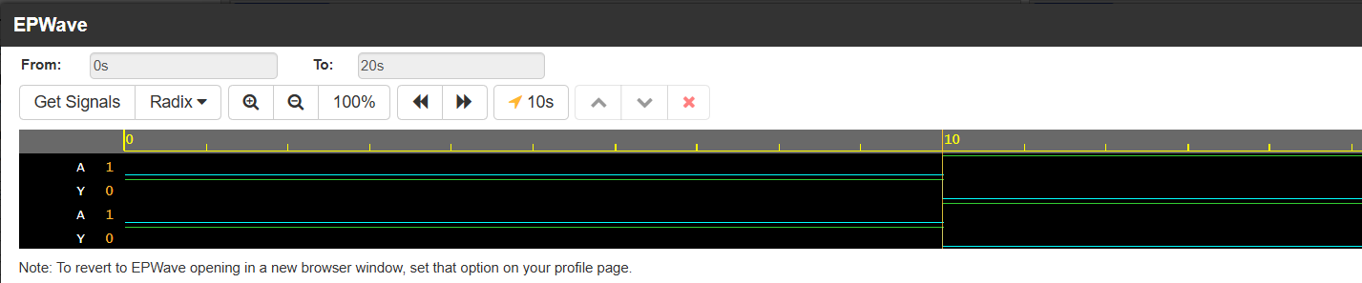

- NAND Gate
- The NAND gate is the complement of the AND operation. Its output becomes LOW only when both inputs are HIGH.
- Y=A⋅B‾
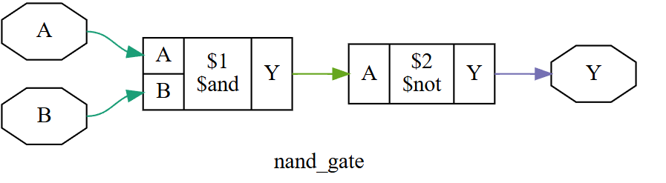
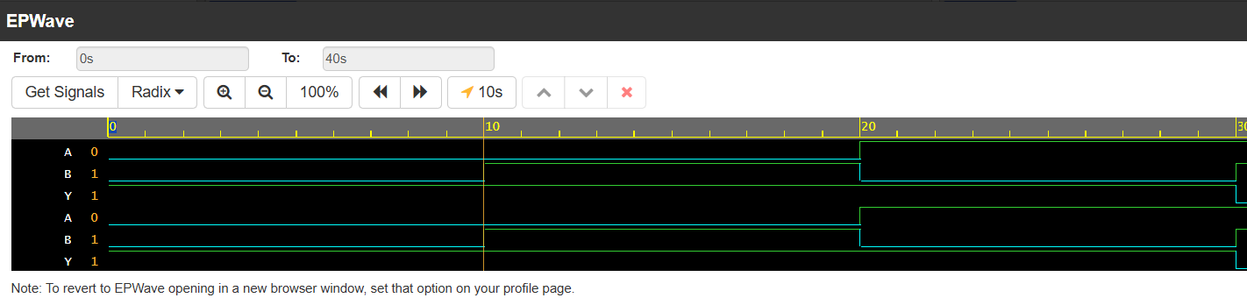
- NOR Gate
- The NOR gate is the complement of the OR operation. Its output becomes HIGH only when both inputs are LOW.
- Y=A+B‾
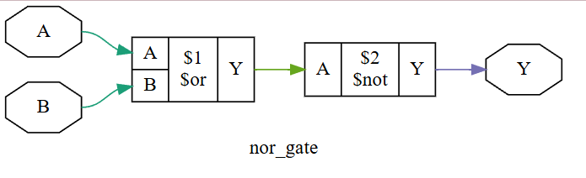
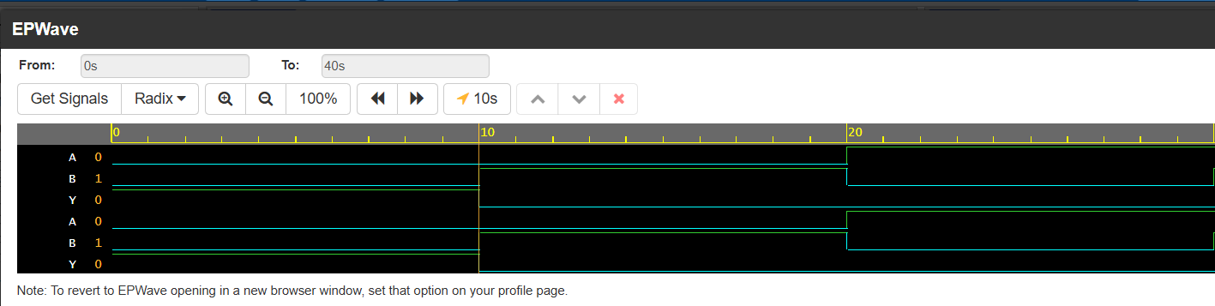

- XOR Gate
- The XOR gate produces a HIGH output when the two inputs are different.
- Y=A⊕B
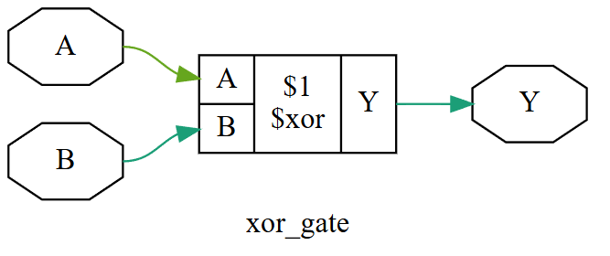
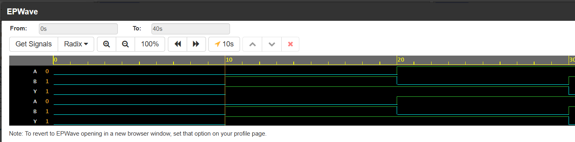
- HALF ADDER
- A Half Adder is a combinational circuit used to add two 1-bit binary numbers. It has two inputs, A and B, and two outputs, Sum and Carry.
- The Sum is generated using an XOR operation, while Carry is generated using an AND operation.
- Sum=A⊕B
- Carry=A⋅B
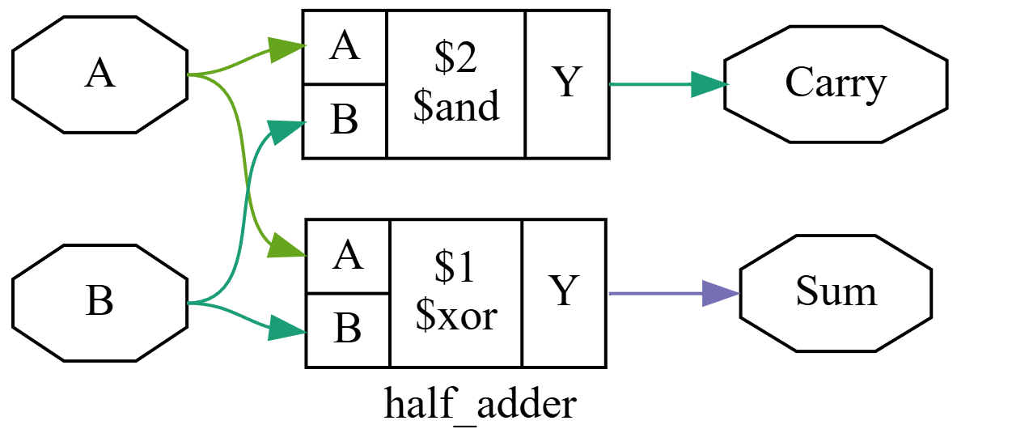
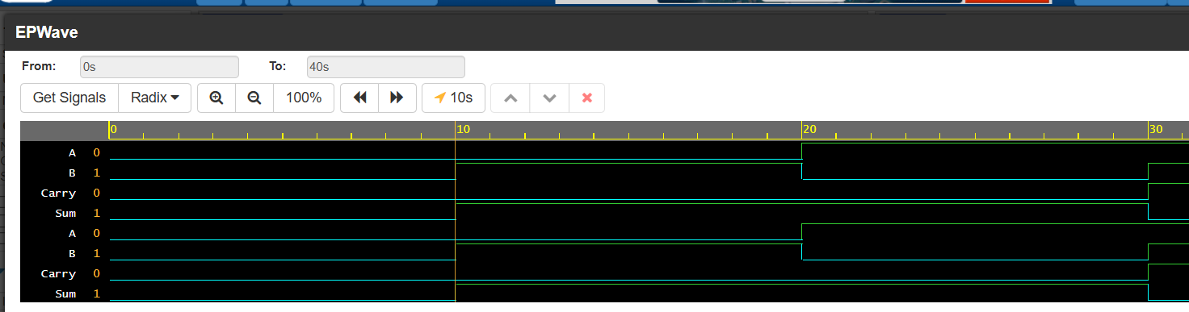
- FULL ADDER
- A Full Adder adds three 1-bit binary inputs: A, B, and Carry-in (Cin). It produces two outputs, Sum and Carry-out (Cout).
- The Sum is obtained using XOR operations, while the Carry-out is obtained using AND and OR operations.
- Sum=A⊕B⊕Cin
- Cout=AB+BCin+ACin
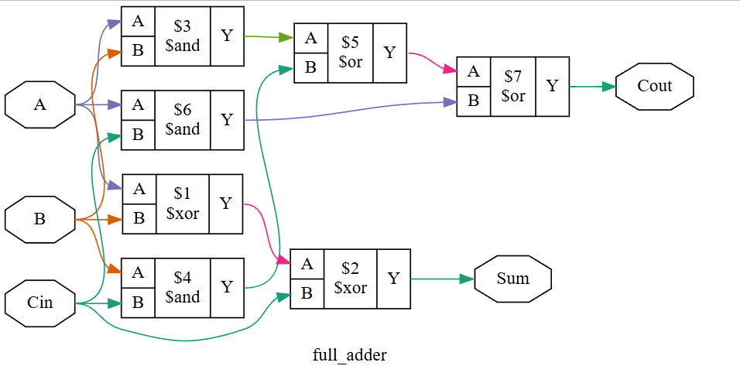
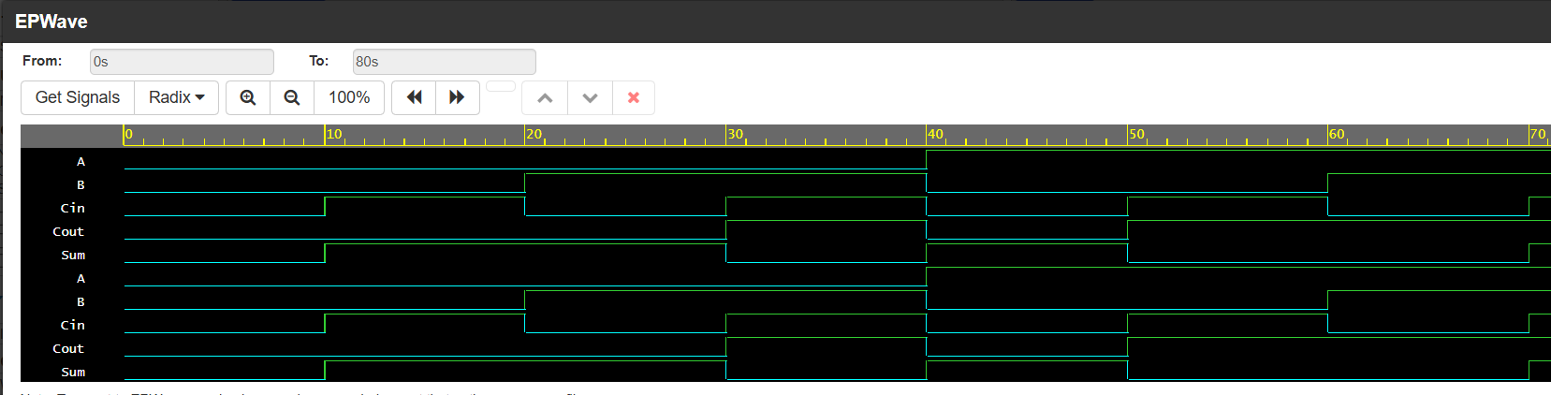

1) Observation
- The basic combinational logic gates such as AND, OR, NOT, NAND, NOR, and XOR were
- A Half Adder was designed to generate the Sum and Carry outputs from two binary inputs.
- A Full Adder was implemented using three inputs, including the carry input, and its Sum and Carry outputs were verified.
- Testbenches were created to apply different combinations of input signals and observe the corresponding outputs.
- The designs were simulated, and the resulting waveforms were analyzed to verify the correct operation of the circuits.
- The obtained simulation outputs were found to be consistent with the expected truth tables and Boolean expressions of the respective circuits.
- The experiment helped in understanding the relationship between Verilog HDL code, RTL design, combinational logic, simulation, and waveform analysis.

2) Conclusion
The experiment successfully demonstrated the use of Verilog HDL for designing and modeling basic combinational digital circuits. Logic gates, Half Adder, and Full Adder were implemented and their functionality was verified through testbench-based simulation. The simulation waveforms confirmed that the outputs obtained for different input combinations were as expected. This experiment provided practical understanding of RTL modeling, Verilog syntax, testbench development, simulation flow, and waveform interpretation, which are essential concepts in VLSI digital design.

